**CIS.600**

**Internet of Things: Security and Privacy**

IN CLASS EXERCISE

ROHAN BHOWMICK

SUID: 658096139

rbhowmic@syr.edu

**Exercise: 1**

1. **How many packets are there?**

* As shown in Wireshark, there are 78 packets.

1. **What networking protocol is used?**

* The protocols in use are:

1. UDP
2. TCP

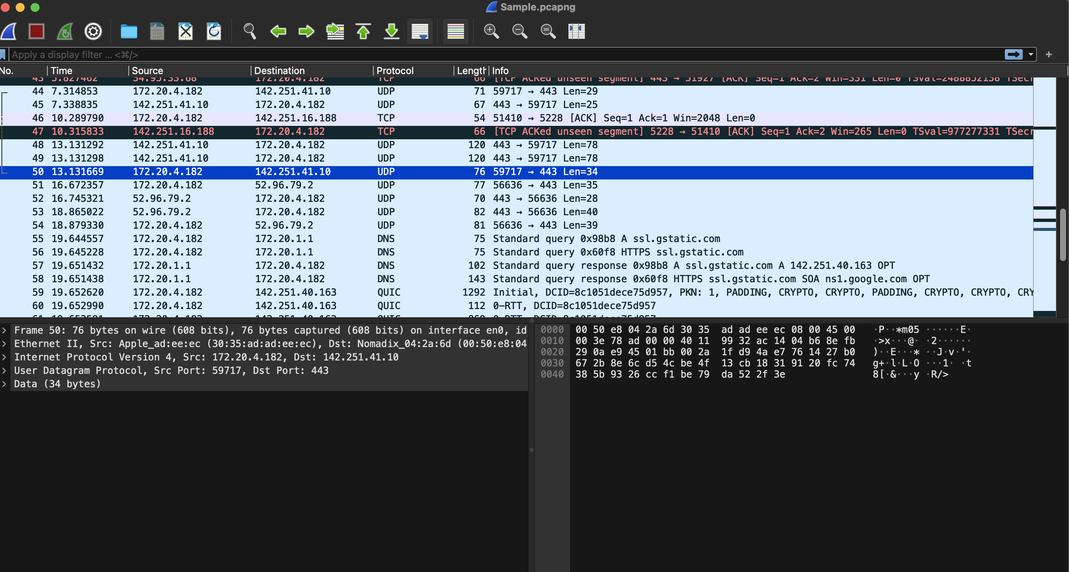

Referring the image above, source IP address and destination IP address can be observed.

For packet number- 50:

1. **What is the source IP address?**

* The source IP address is: 172.20.4.182

1. **What is the destination IP address?**

* The destination IP address is: 142.251.41.10

1. **What port number is the source using to communicate with the destination (or what port number is the destination listening on)?**

* The destination port number is: 443.

1. **Do you notice the “three-way handshake”?**

* No, there appears to be no three-way handshake present in this given case.

**Exercise 2:**

**Reconstructing a conversation • Click on a packet (it will be highlighted in blue) • Right-click on packet • Go to “Follow” • Follow one of the following streams depending on protocol (UDP Stream is most common)**

* **Refer the image below:**

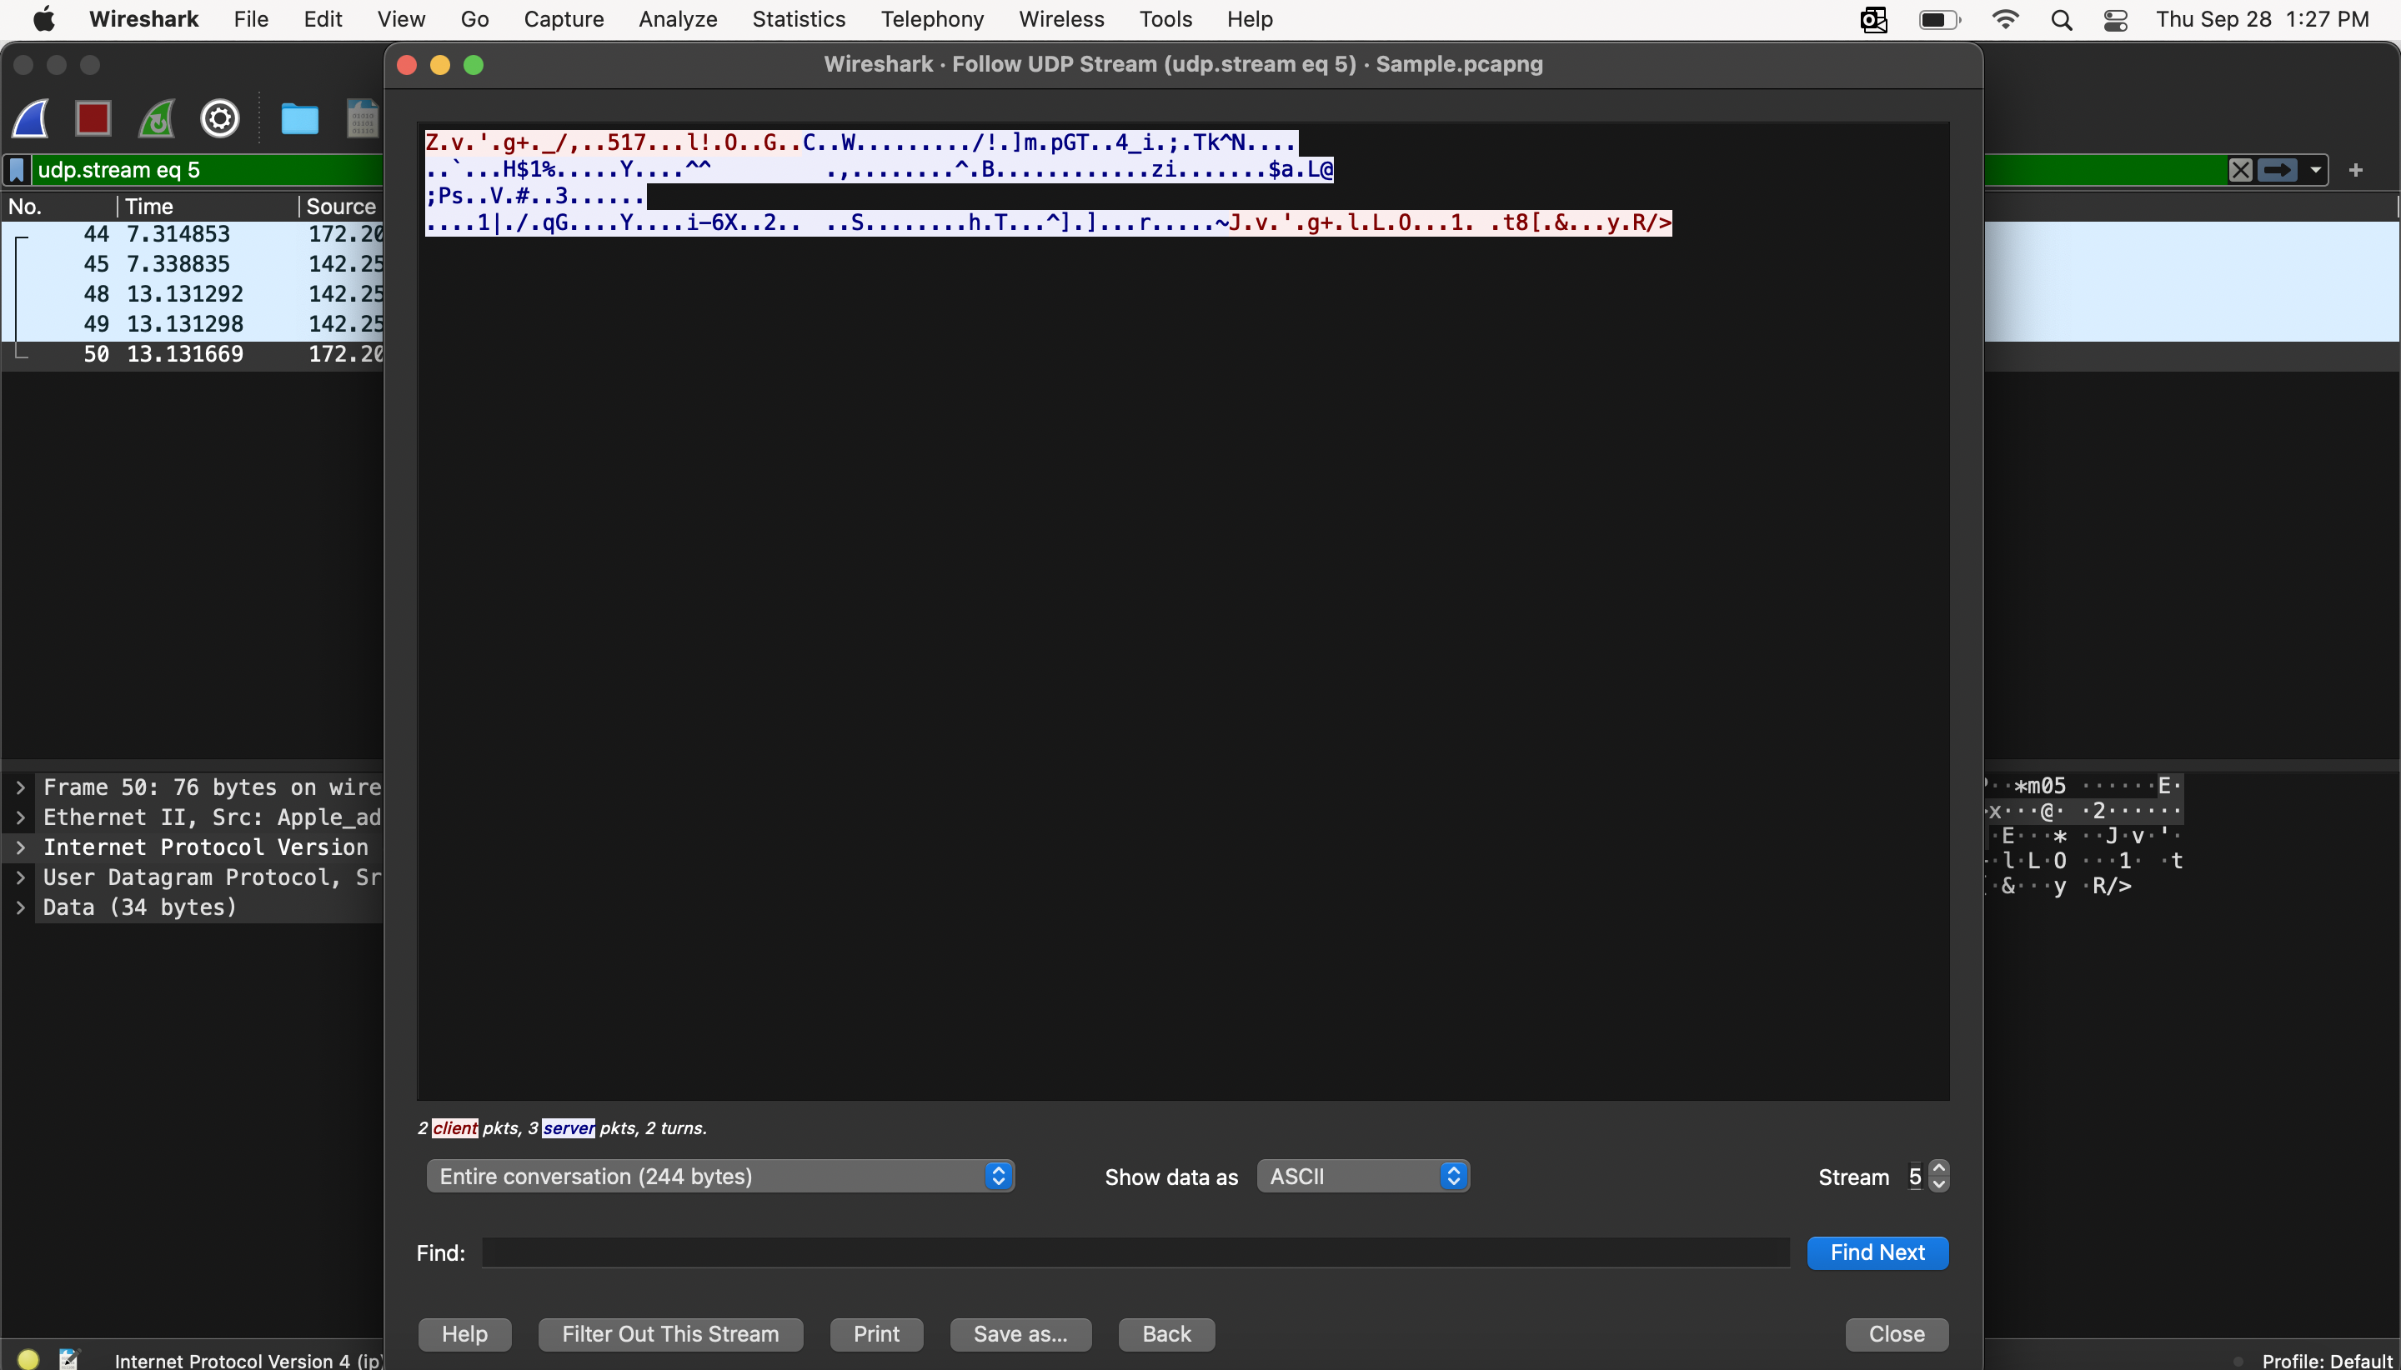

Conversation in text:

Z.v.'.g+._/,..517...l!.O..G..C..W........./!.]m.pGT..4_i.;.Tk^N....

..`...H$1%.....Y....^^ .,........^.B............zi.......$a.L@

;Ps..V.#..3......

....1|./.qG....Y....i-6X..2.. ..S........h.T...^].]...r.....~J.v.'.g+.l.L.O...1. .t8[.&...y.R/>

**Exercise 3:**

**Finding transmission protocols**

**• To see all protocols in a Wireshark capture, you can go to Statistics > Protocol Hierarchy. This will show a list of all protocols, along with the number of packets and bytes for each protocol.**

**• You can also examine capture file properties by going to Statistics > Capture File Properties. This will show general information about the PCAP file, including the first and last packets, timestamps, and the total number of packets.**

**• To filter to a particular stream, you can select a packet in the packet list and then select the menu item Analyze → Follow → TCP Stream.**

**• You can also find packets by selecting Edit → Find Packet in the main menu.**

* **Seeing all protocols in a Wireshark capture:**

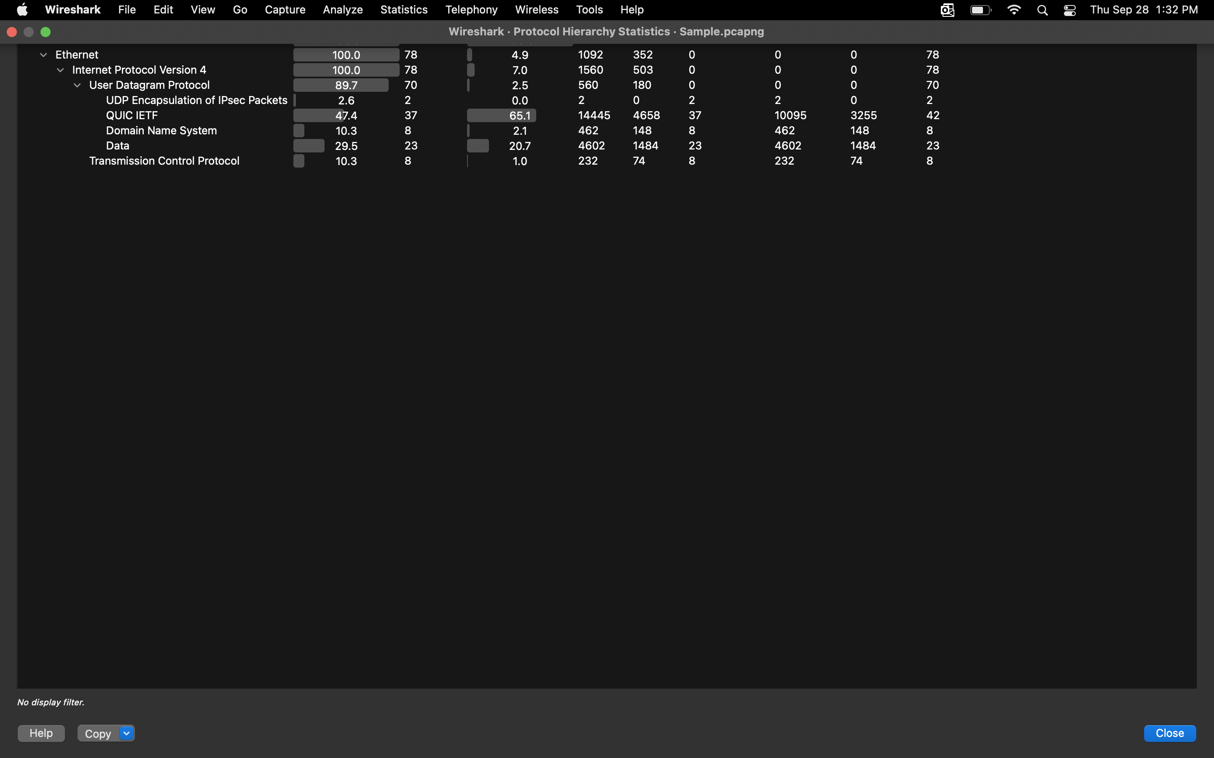

* **Examining capture file properties:**

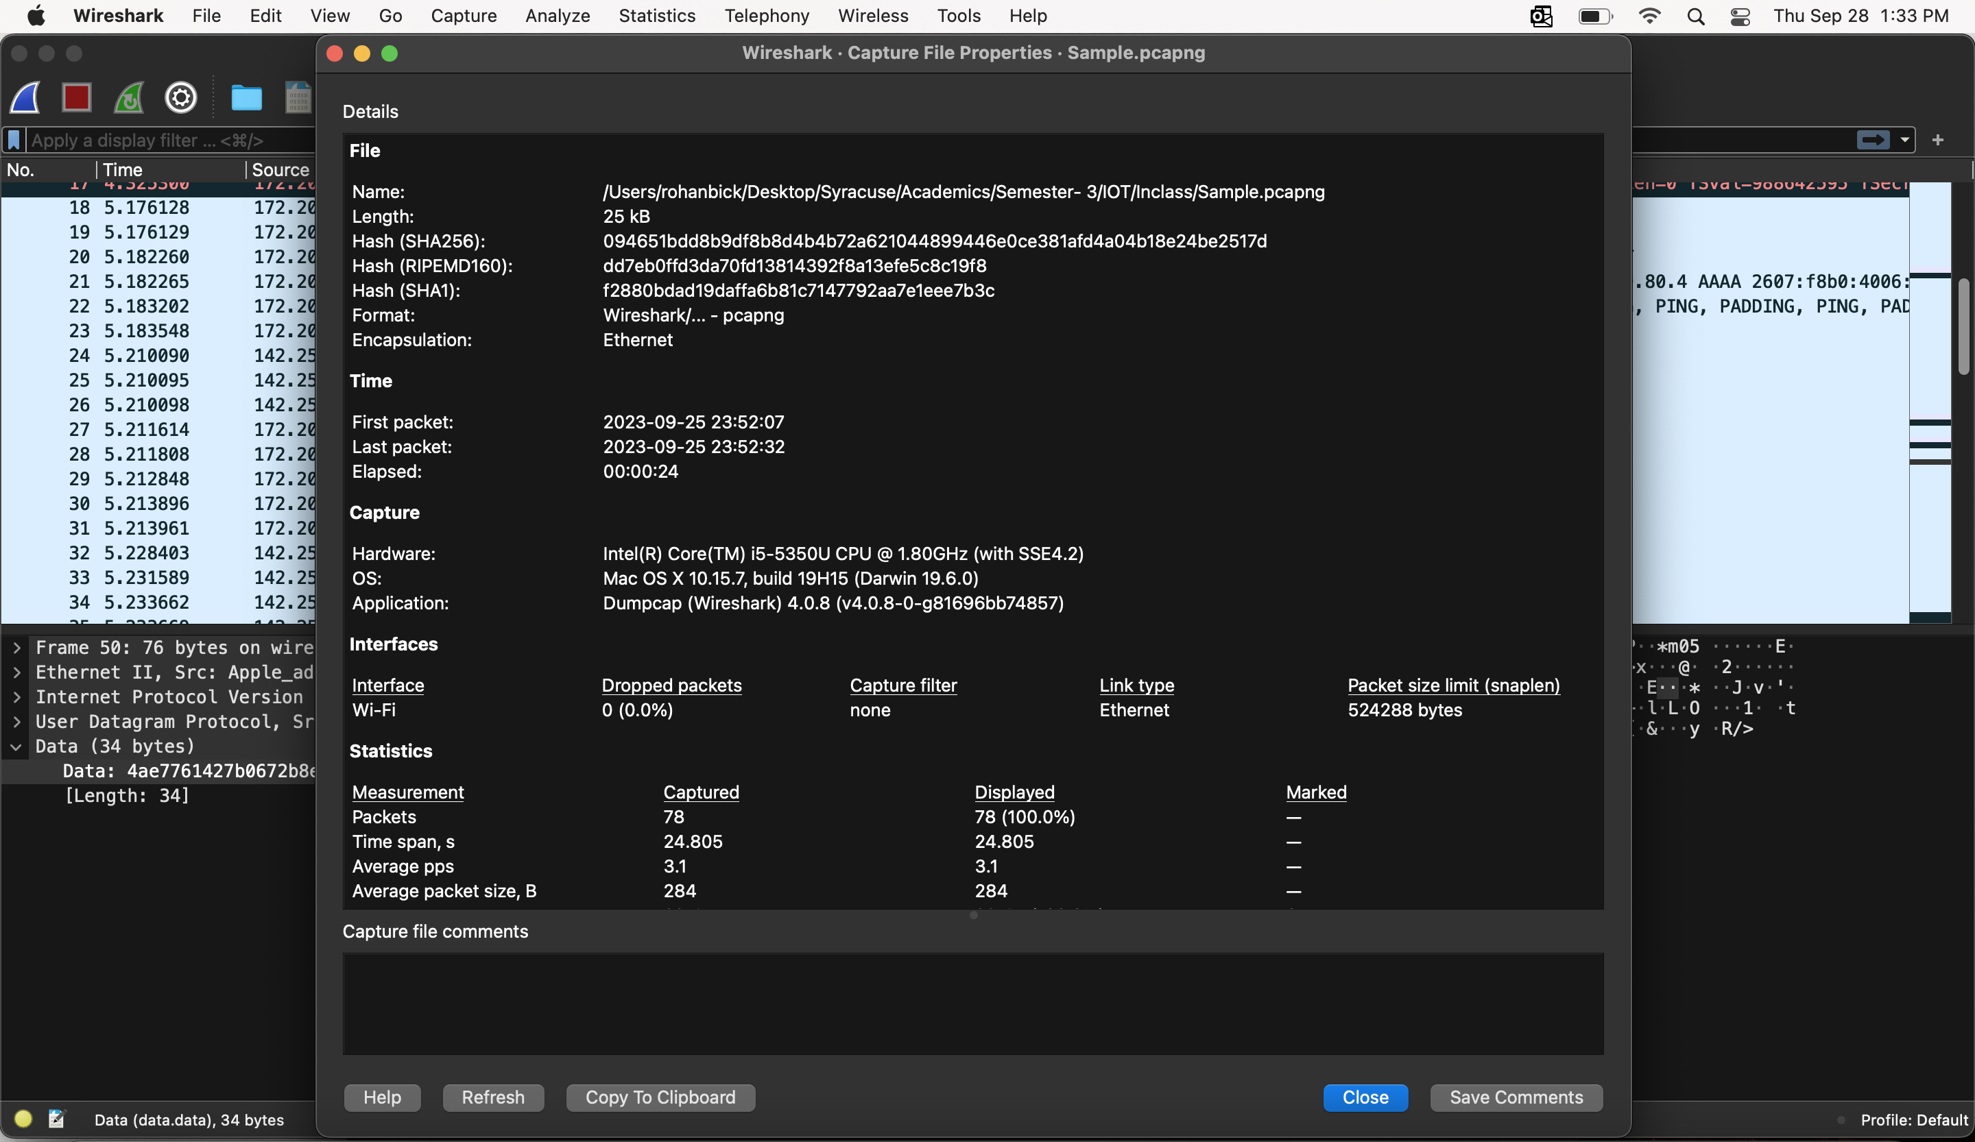

* **Filtering to a particular stream using Analyze:**

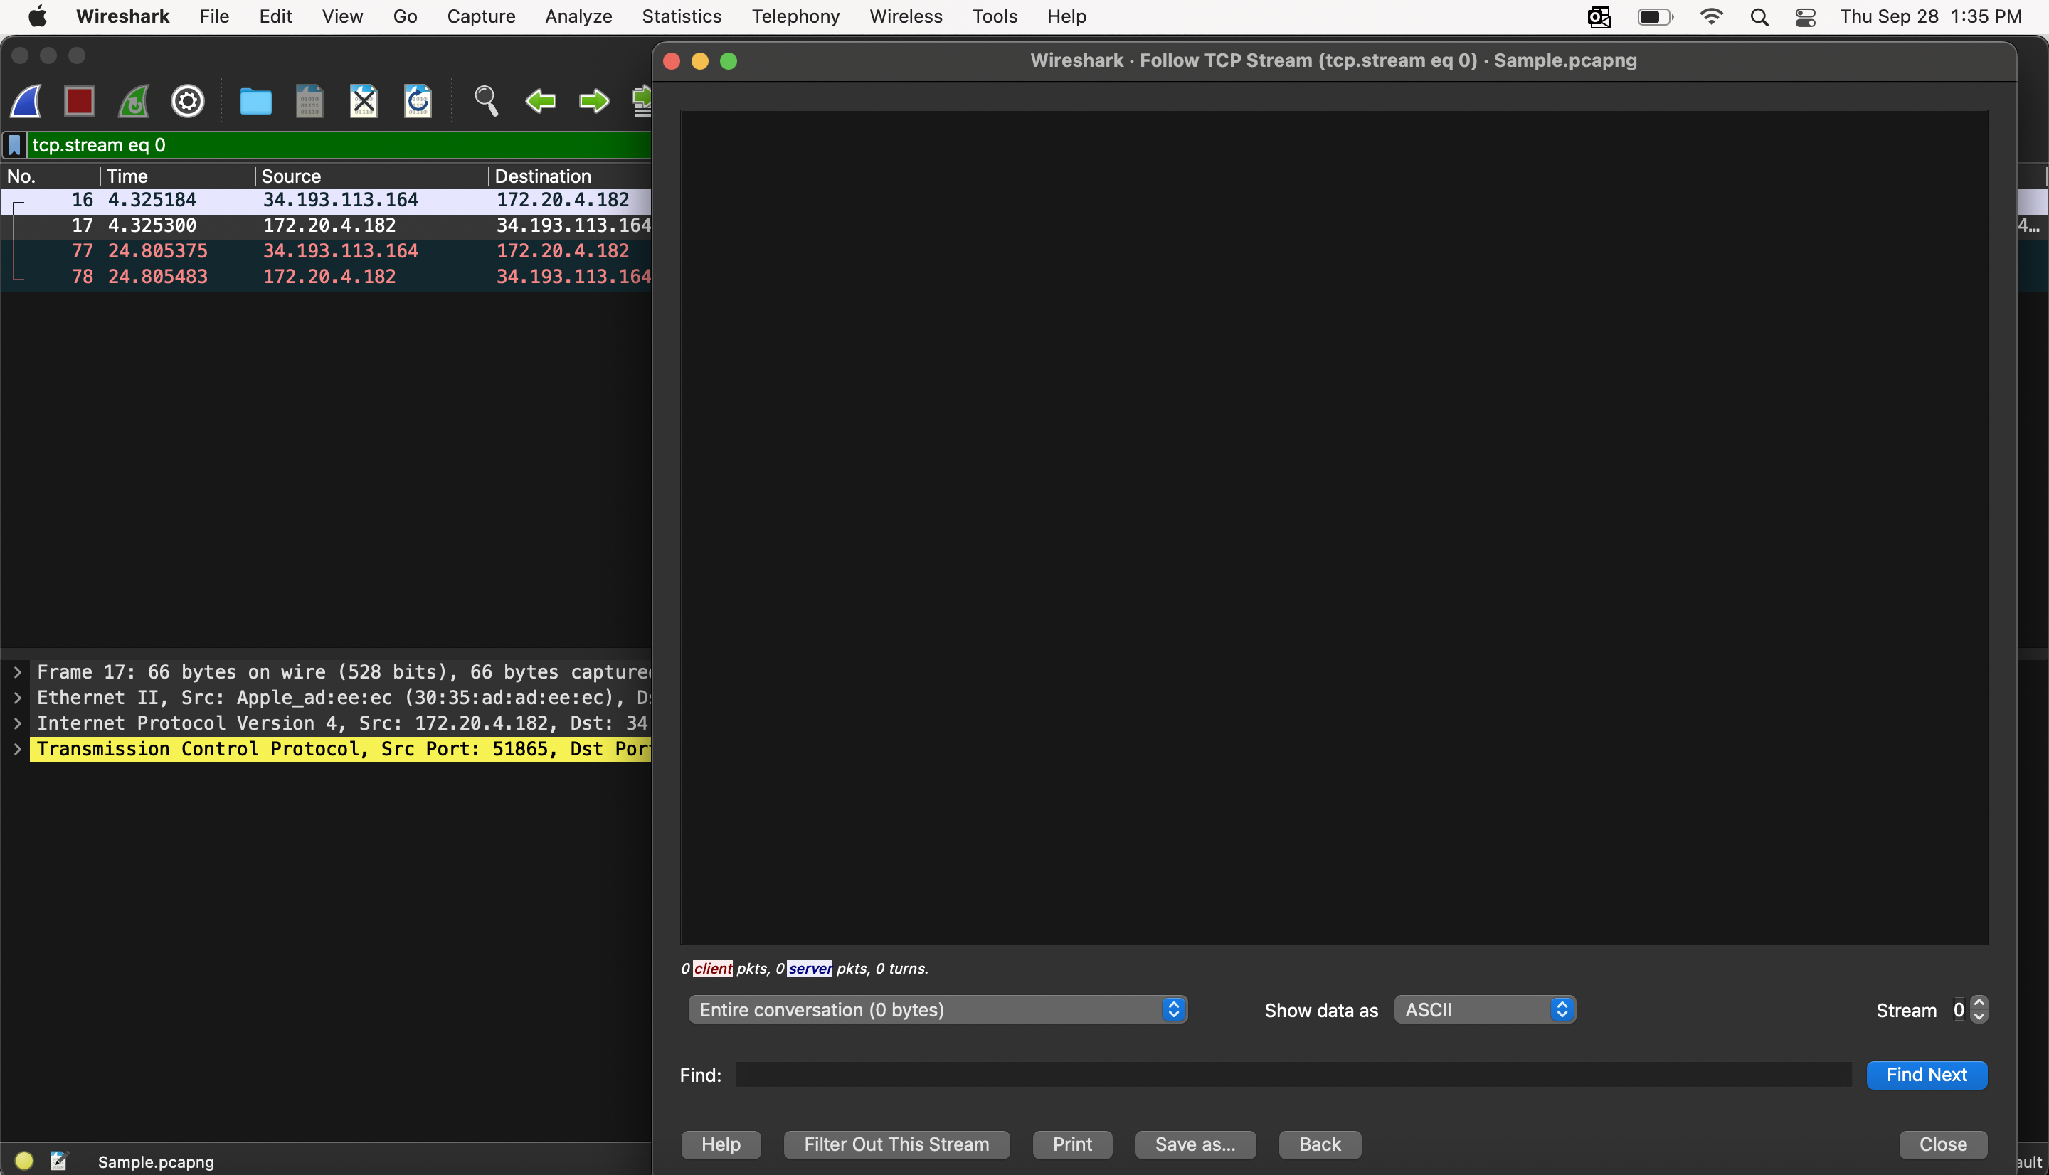

* **Finding packets:**

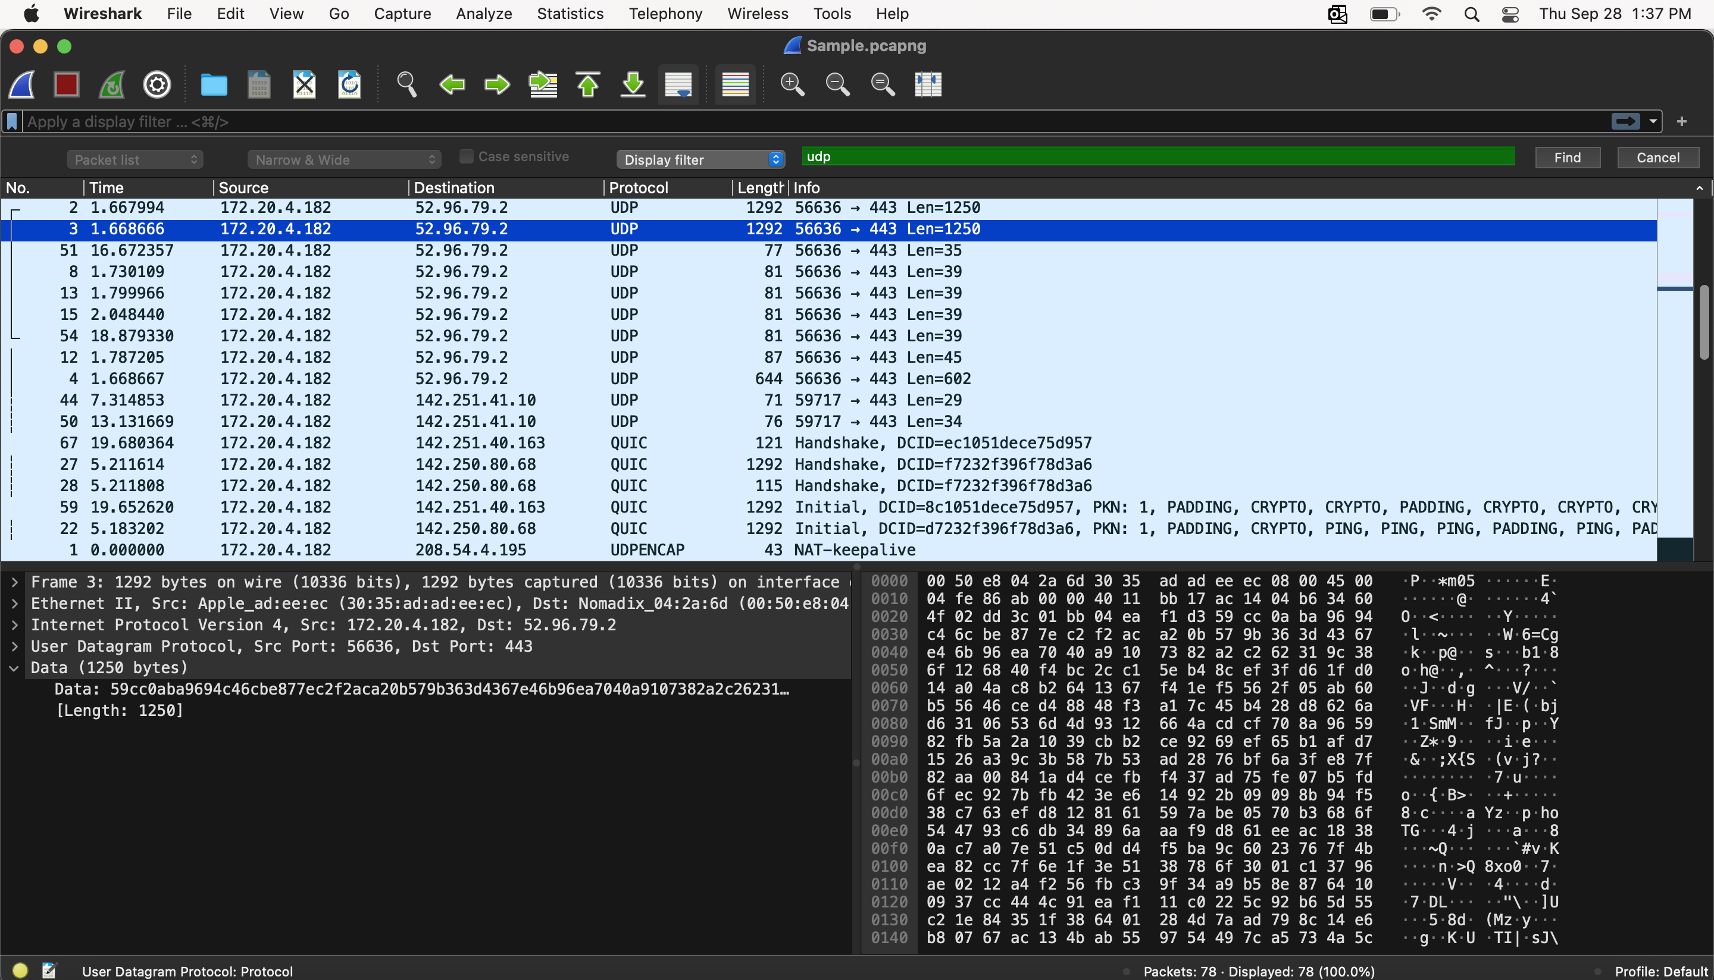

1. **What insecure protocol was used to transmit pictures on network?**

* FTP protocol is the insecure protocol used here.

1. **How many pictures were transmitted?**

* 2 packets (pictures) were transmitted.

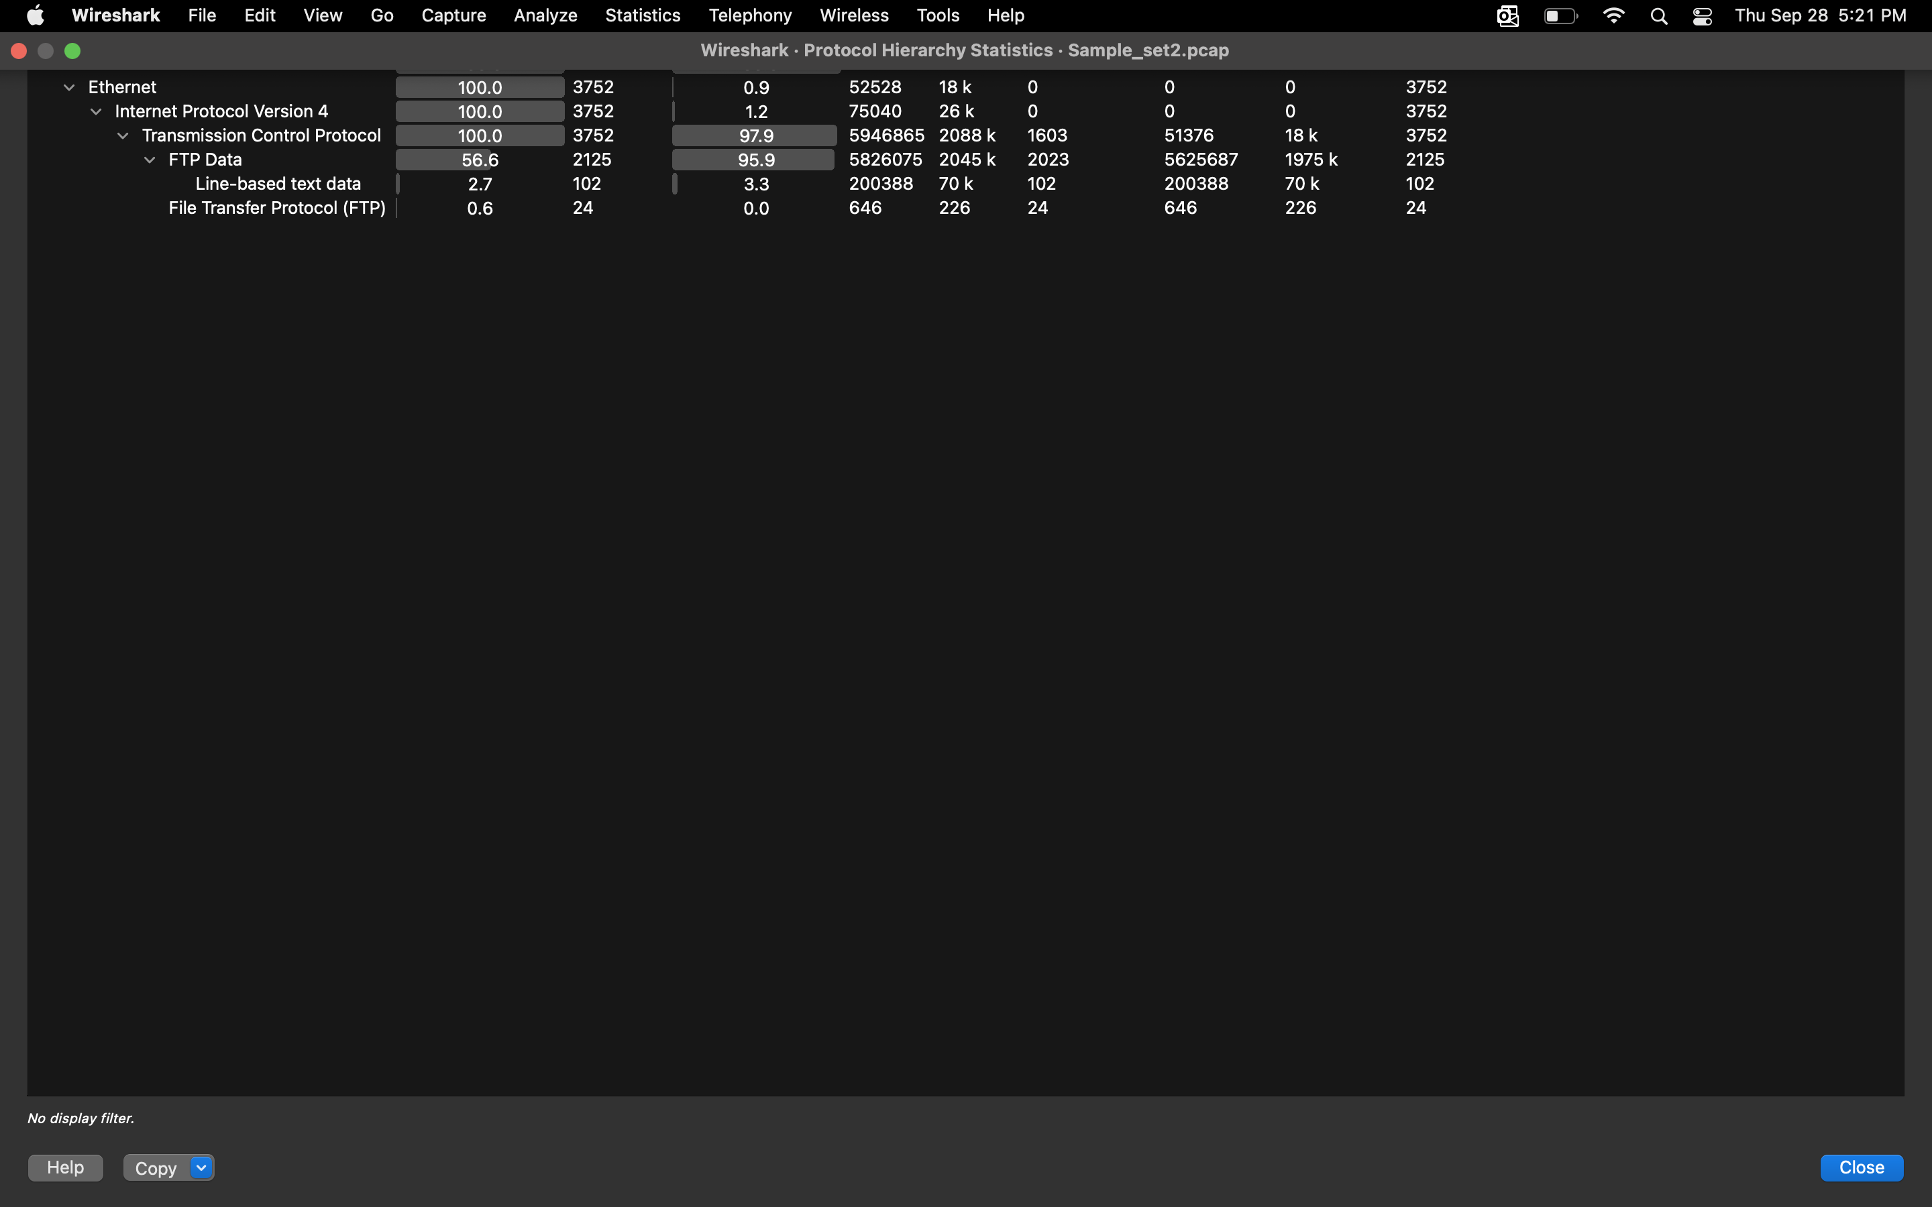

1. **Extract one of the pictures that was transmitted. HINT: show and save the picture as “Raw” format. (saved with .jpg extension)**

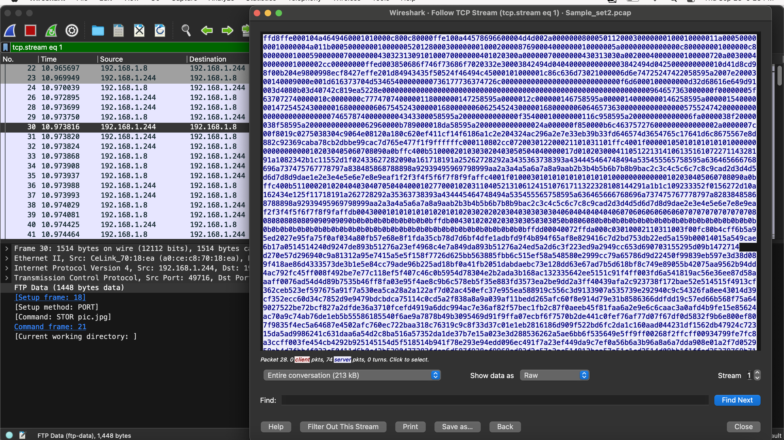

The image saved is shown below:



**Exercise - 4:**

1. **What protocol was used to transmit the username:password pair (credentials)?**

* IMAP protocol is used to transmit the credentials as shown in the image below.

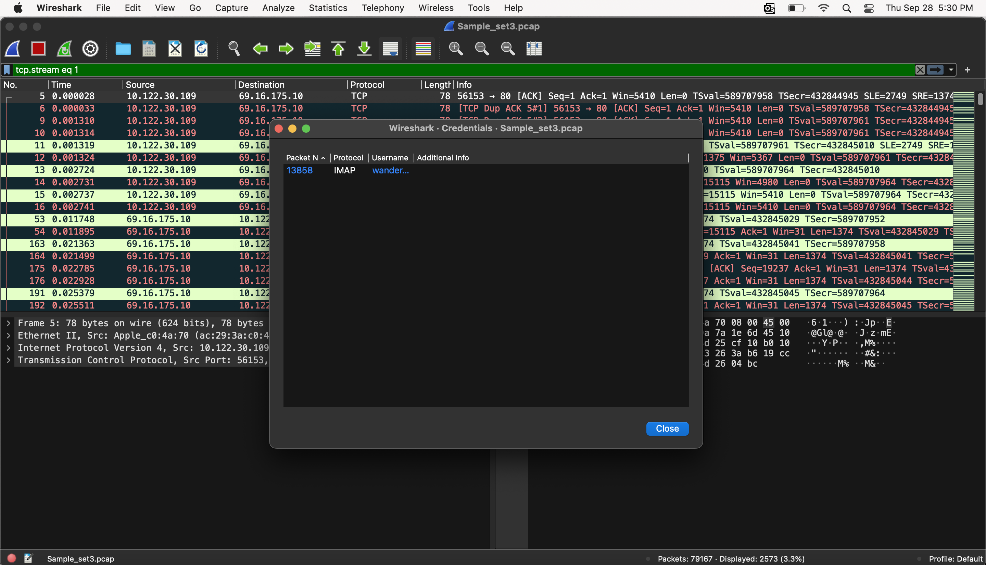

1. **What is one username:password pair in this PCAP set? (HINT: use Edit > Find Packet)**

* When searched for requests containing ‘http’, got a request containing Login details that were part of a login request with username and password in it as shown below in the image.

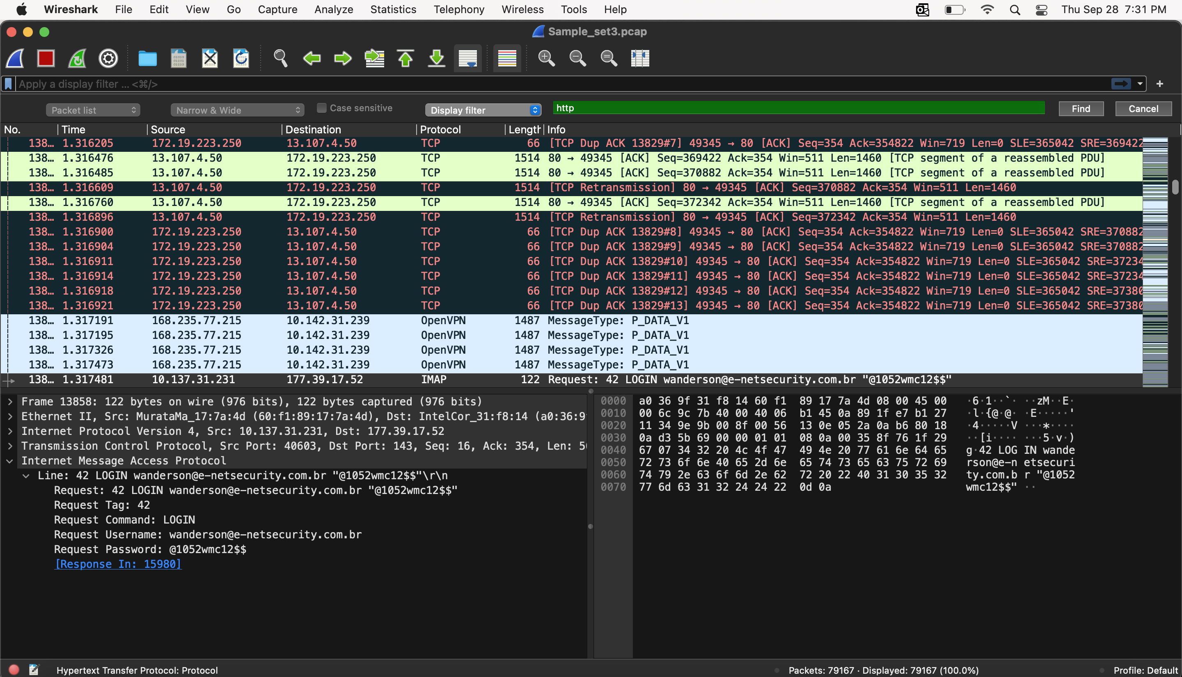

1. **Is the username:password pair valid? Why / why not?**

* After getting the details of the http request as shown in above image with username and password.
* When clicked on the response, it showed the message containing Response Status as ‘OK’ with Response Tag as ‘42’ and Response Command as ‘LOGIN’.
* Hence, the username: password pair given in the request is valid.

